horizontal line

**Delhi Technological University**

Department of Applied Physics

IVth Semester

**MICROPROCESSORS & INTERFACING**

**MPI EP - 206**

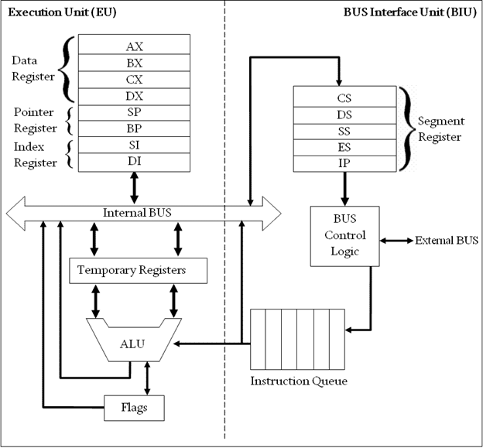

# **Submitted by :**

**ADITYA SINGH, 2K19/EP/005**

**Submitted to:**

**Dr. Rishu Chaujar**

# **Experiment 1**

**Addition of two 64- bit numbers**

**THEORY**

1. Include the emu8086.inc library and start the data and code segments.
2. Input the first number into the AL register using the int 21h interrupt.
3. Subtract 48 (ASCII value of 0) form the AL register to convert the number into decimal from ASCII.
4. Store this number into the BL register.
5. Print a newline and return carriage to the new line .
6. Input the second number into the AL register and repeat step 3.
7. Add the two numbers and store the sum in the BL register.
8. Add 48 to the sum to convert it back to ASCII.
9. Repeat step 5 and print the sum to the output screen.

**CODE**

include "emu8086.inc"

.data

.code

main proc

print "First Number: "

mov ah,01h

int 21h

sub al,48

mov bl,al

mov dl,10

mov ah,02h

int 21h

mov dl,13

mov ah,02h

int 21h

print "Second Number"

mov ah,01h

int 21h

sub al,48

add bl,al

add bl,48

mov dl,10

mov ah,02h

int 21h

mov dl,13

mov ah,02h

int 21h

print "Sum : "

mov dl,bl

mov ah,02h

int 21h

main endp

end main

**OUTPUT**

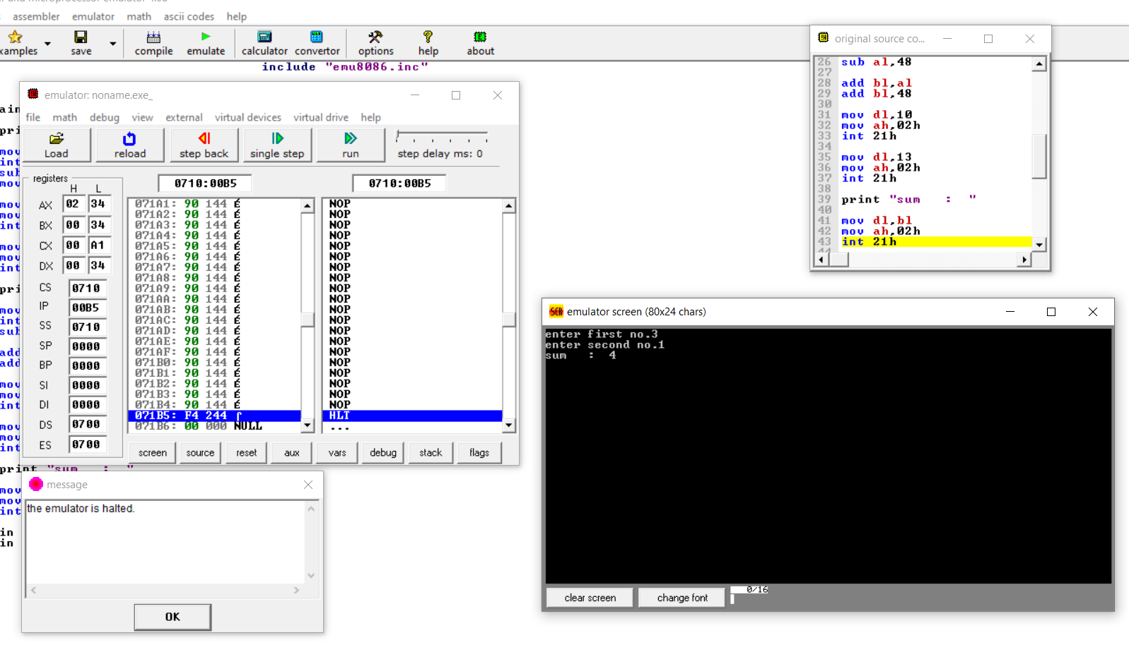

**END**